TOWN OF STAFFORD
Est. March 24, 1820

P.O. BOX 52  ROBERT S. CLEMENT  Supervisor  RONALD PANEK  Deputy Supervisor  BARBARA RADLEY  Town Clerk | 8903 ROUTE 237  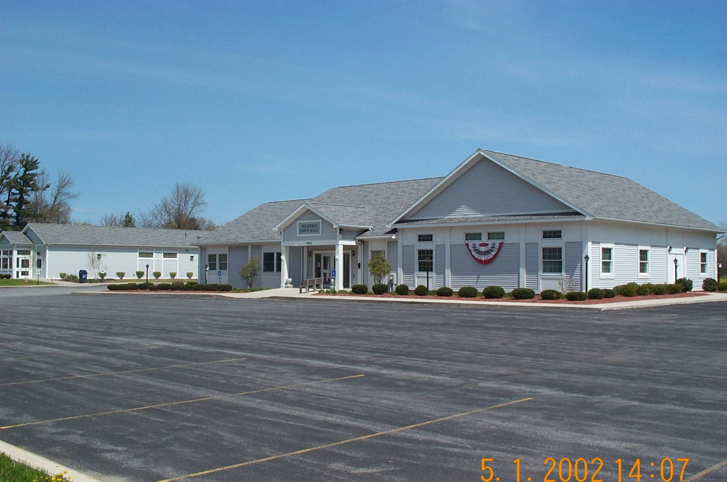  JAMES DUYSSEN  ROBERT PACER  TERRY YOUNG  Councilmen | STAFFORD, NEW YORK 14143  WWW.TOWNOFSTAFFORD.COM | Phone: [585] 344-1554  STEVEN BOLDT  Highway Superintendent  ROBERT MATTICE  ROBERT PENEPENT  Town Justice | Fax: [585] 345-0592  LORI FRONGETTA  Assessor  GENE SINCLAIR  Code Enforcement Officer

ZBA MEETING AGENDA
MARCH 17, 2025

- Approval of January 20, 2025 Meeting Minutes
- Accept Resignation Letter
- Training Opportunities
- Other Business
- Adjournment

